**Question#01:**

A university is admitting students in a professional course subject to the following conditions:

(a) Marks in Java ≥ 70

(b) Marks in C++ ≥ 60

(c) Marks in OOAD ≥ 60

(d) Total in all three subjects ≥ 220 OR Total in Java and C++ ≥ 150

If the aggregate mark of an eligible candidate is more than 240, he will be

eligible for scholarship course, otherwise he will be eligible for normal course.

The program reads the marks in the three subjects and generates the following outputs:

(i) Not eligible

(ii) Eligible for scholarship course

(iii) Eligible for normal course

Design the solution for this program using decision table testing.

**Solution**

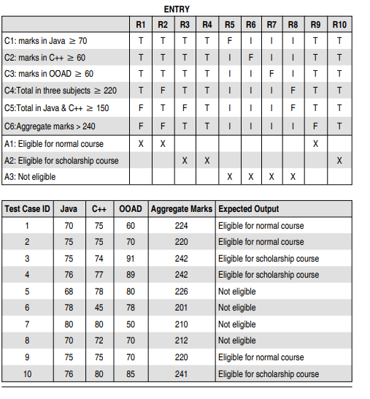

**Question#02:**

**https://blog.issart.com/real-life-examples-of-how-to-use-pairwise-technique-in-test-design/**